POWER MOBILITY USE AT HOME, SCHOOL & IN THE COMMUNITY

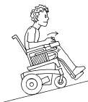

SUPERVISORS GUIDE FOR SAFE DRIVING FOR
ALL POWER MOBILITY LEARNERS

This resource is intended for use by parents/caregivers or other adult supervisors (e.g., Educational Assistant) that support and supervise children (under 19 years of age) as part of the training provided by the child’s therapist in safe use of the power mobility device. It has been developed by a team of occupational therapists at Sunny Hill Health Centre and is based on current (2020) research and expert clinical opinion.
Supervisors are those adults who supervise children using power mobility devices. The following individuals were trained in safe power mobility device use:
CHILD’S NAME:
SUPERVISOR’S NAME | DATE
Learning Trajectories
There are typically three different learning trajectories for those learning to use a power mobility device. These include exploratory learners who are just beginning to learn cause-effect and explore movement; operational learners who are learning to direct their movements more intentionally to maneuver around obstacles but who need ongoing supervision to be safe - their use may be limited to specific activities and environments; and functional learners who quickly understand how to steer and are learning to use the device to participate in activities with other children in a variety of environments.

This guide has been developed to be used in conjunction with the appropriate Learners’ Checklists for Parents/Caregivers and School Teams. Therapist(s) should review this Supervisor’s Guide and recommendations with all adults who will use the power mobility device with the child; then individualize the appropriate checklist (with parents, caregivers and/or school and community team members) to support the child’s safe use of the device in all desired settings. These recommendations and checklists should be reviewed and updated regularly by the therapist to match the child’s progress and development.

To address safe use in specific situations, please choose one of the three power mobility use Learners’ Checklists below that best matches the child’s current power mobility skill level:

- Exploratory Learners

- Operational Learners

- Functional Learners

As Learners develop, they can be introduced to additional relevant skills.
General Principles for Learning to Use Power Mobility Devices
Do:
- Let the child learn by doing, give them time to learn and react.
- Let the child lead their exploration and play (rather than directing them). Be comfortable with being quiet. If needed, provide brief and positive commentary on their experiences (e.g., “You found the ______ [object the child ran into]” rather than “Oops, you crashed”).
- Give the child time to figure out a situation before intervening. However, if the child looks distressed, then intervene immediately.
- Encourage learning by making “mistakes”. For example, they need to safely bump into things to learn boundaries and object permanence.
- Watch your tone of voice. Try to keep your voice soft and encouraging. Help the child by using consistent, clear, short phrases such as “come closer”, “turn”, “go back”, “lift your hand off”, or “let’s go for a walk”, rather than “push the joystick and come here” or “go forward, turn left, and then go in reverse”.
- Encourage the child’s own problem-solving such as “try another way”.
- Ensure the process is enjoyable and rewarding (stop before child is tired or frustrated).
- Be aware that the child will first explore the joystick/switch(es), then become aware of moving through space before they pay attention to people and objects around them.
Do Not:
- Expect the child to learn how to operate and maneuver the device within days or weeks. This is a gradual learning experience and for many it may take months or years. The goal is to give the child a way to move, explore, discover, and problem solve at their own pace.
- Use negative language (e.g., “You’re going the wrong way”), or be directive.
Describe how to move by using directions and commands (e.g., “Turn this way,” “Go forward” “Turn right or left”). Instead, play the role of commentator, describing their actions as they explore their surroundings.

Level of Supervision: Supervision is critical for both safety and optimal learning. Please refer to the corresponding Learners’ Checklist provided by the therapist for specific recommendations for the child (e.g., close or stand-by or at-a-distance supervision). Please note: In general, children should only use the power mobility device under the supervision of a trained adult. Some children will always require close and constant supervision to ensure safety. Children who are more proficient will continue to require an adult to oversee and monitor general use and safety although they may not require close and constant or stand-by supervision.
The information on the following pages is critical for all supervising adults, regardless of the child’s learning trajectory.
Power Mobility Device Owner’s Manual & Troubleshooting:
- You should have access to the owner’s manual (a copy of manual or an online link through the manufacturer’s website). It is important to review the information on how to charge and maintain the power mobility device and know who to contact for problems and trouble shooting. The power mobility device is not to be used if the electronic controls (e.g., joystick or switches), brakes or any other crucial components are known to require repair.
Equipment Safety & Precautions:
- Prior to operating the power mobility device, ensure that all needed fastenings on the seating system, including the seat belt, are done up correctly and securely.
- Ensure the power mobility device is not turned on until the armrest and joystick or alternate controls (switches) are in a driving position (e.g. not when flipped up or back).
- When not driving, the power mobility device should always be turned off (either by the child or the attendant) to minimize accidental activations.
- Depending on age and ability, discuss and encourage the child to pay attention to surroundings and potential hazards for safety. Train for safe operation including awareness of the environment and others moving quickly and unpredictably. Strategies can include stopping and waiting for others to pass or teaching other children to be courteous and give way.
- Review safety precautions with other children as appropriate, to increase their awareness of the power mobility device and general precautions, such as how to behave when near the device, where to stand and how to cross the device’s pathway and need to ask permission to touch the device, etc.
- Additional safety features, such as programmable maximum speed(s), emergency stop buttons, and attendant controls should also be reviewed as applicable.
Applying Brakes & Manual Release of the Wheel Locks:
  - As applicable, use the emergency stop button or attendant controls to restrict movement in an unsafe situation.
  - Use the ‘free-wheel’ position* with caution - i.e. only to get the power mobility device out of a tricky situation (e.g., after getting stuck or to avoid an unsafe situation). (‘Free-wheel’ position: when the electronic brakes have been dis-engaged to enable manually pushing from behind - usually by releasing the wheel lock levers, on each side, near the wheels).
  - Ensure that the power mobility device is on a level and dry surface before releasing the wheel lock levers to avoid the wheelchair rolling away. Be aware that the motors will not be engaged and that the power mobility device will not have electronic brakes when the wheel locks are disengaged in the ‘free-wheel’ position.
  - If the power mobility device were to get stuck on an incline and the wheel locks need to be released so that the device can be manually pushed free, the child should first be transferred out of the device (to an alternate manual wheelchair or other chair) for safety.

Transfers:
- Transfers into and out of the power mobility device should be supervised by a trained adult.
- Ensure the device’s power is turned off for all transfers, that is before entering or leaving the power mobility device and before lifting the control-side armrest (if using hand controls) or headrest (if using head controls).
- Ensure the device’s electronic brakes are engaged prior to beginning transfer in order to prevent accidental device movement during transfer.
- Position the power mobility device as close as possible to the transfer surface when transferring into or out of the wheelchair to avoid loss of balance, a fall or injury.
General Safety Precautions
- For children who require close or stand-by supervision for safety, the supervising adult should walk closely beside the child (especially when in areas of higher risk, like on a sidewalk, in a crowd, or in a parking lot). The adult should be directly next to the joystick/switch(es), attendant control and/or emergency stop button to assist immediately as needed if safety becomes a concern.
- Remind the child to maintain a speed that is compatible with the walking speed of the supervising adult.
- Drive slowly on uneven surfaces or in new settings.
- Drive slowly when in the company of others. Be prepared to stop quickly if needed.
- Lower driving speed when approaching stationary objects (e.g., fence, bike rack).
- When turning, reduce speed and reduce the sharpness of turn to minimize risk of tipping.
- Be cautious going out in wet, stormy, snowy or icy weather conditions. Surfaces covered with wet leaves, mud, snow, or ice, may be hazardous. Do not proceed if safety may be compromised.
- Be aware of all local pedestrian rules (e.g., stopping and looking both ways before crossing a pathway, staying to the right on pathways, stopping fully and looking both ways before entering a parking lot or when negotiating ramps). The child may require specific and on-going education about these rules.
- Be aware that drivers in a parking lot may have difficulty seeing the child because of the height of the wheelchair. Discuss strategies on how to handle this.
- Drive on sidewalks where available, staying closer to the centre of the sidewalk and avoiding sidewalk edges for safety reasons. As much as possible, avoid driving the power mobility device on public streets or roadways.
Gradients & Slopes:
- Take care when on slopes, inclines, and sideways gradients.
- Avoid steep slopes, uneven and soft surfaces (such as grass, gravel, sand, wood chips or moss-covered ground) or sidewalks and ramps with high, sharp/steep edges (especially those without edge protection).

Driving over Curbs, Curb Cuts, Obstacles or Thresholds:
- Take care when driving over curbs, curb cuts, obstacles or thresholds. Do not drive the power mobility device over high obstacles if at all possible (such as curbs or tree roots). Driving over tall edges increases the risk of tipping over as well as the risk of damage to the wheelchair. Negotiating obstacles must always be done with great care.
- Approach thresholds and bumps straight on (i.e., perpendicularly), rather than at an angle where wheels on one side of the device go up before the other side and increase risk of tipping.
- Pay attention to the orientation of the front casters. Ensure there is enough distance so that casters are in trailing position before encountering the threshold/bump (this means that the casters are pointing in the desired direction and are behind the vertical stem rather than being turned or pointing backwards). Drive straight forward (i.e., perpendicularly) at the threshold/bump with the casters in the trailing position.
- Pay attention to speed. Ensure that the child is not traveling too quickly yet has enough power and momentum to clear the thresholds/bumps.
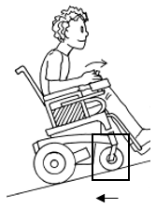

When the casters are in trailing position they won’t turn as the child is going up the bump. This is important because turning casters can increase the risk of tipping.

Image reprinted with permission from “The Powered Wheelchair Training Guide” by Axelson, Minkel, Perr, & Yamada. PAX Press. Copyright © 2002. Credit Beneficial Designs.
Driving on Sideways Slopes:
- Do not attempt to drive across steep slopes, which can cause the power wheelchair to become unstable. That is, do not drive the wheelchair where the sideways gradient is more than indicated in the technical specifications section of the manual.
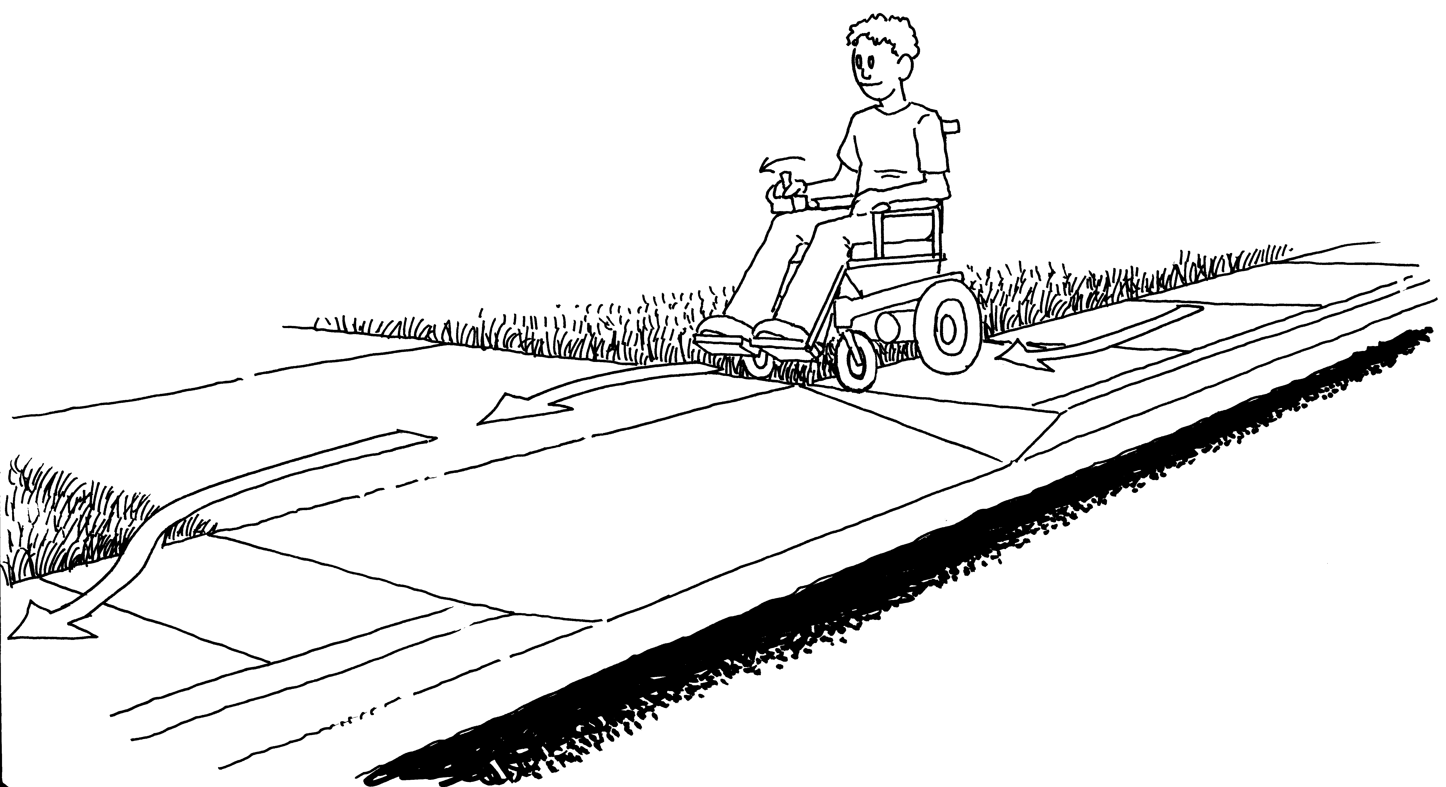

Image reprinted with permission from “The Powered Wheelchair Training Guide” by Axelson, Minkel, Perr, & Yamada. PAX Press. Copyright © 2002. Credit Beneficial Designs.
- Never drive at full speed across slopes as there is increased risk of veering sideways or tipping. Ideally, it is best to drive across the (upper) more level side of a slope.
- When on a slope, the supervising adult should be positioned on the downhill side of the child in the wheelchair and in a suitable position to prevent the child from losing balance or veering into the street.

Driving Uphill:
- As appropriate, lean forward when driving up hills and ramps, moving at a steady pace.

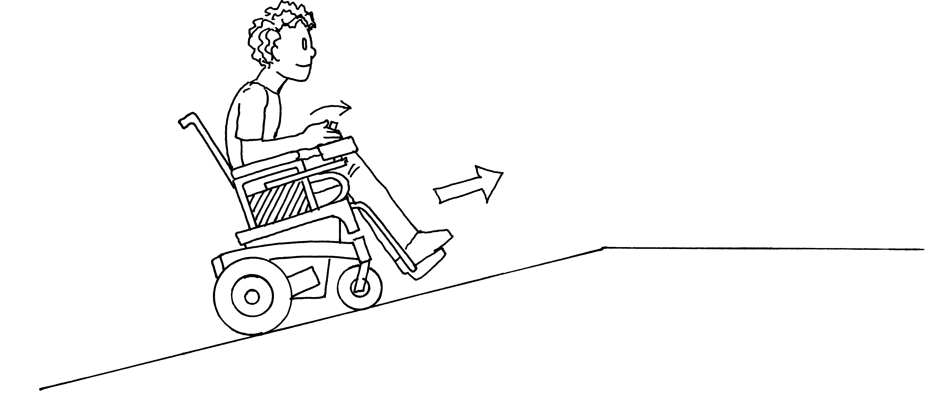

Image reprinted with permission from “The Powered Wheelchair Training Guide” by Axelson, Minkel, Perr, & Yamada. PAX Press. Copyright © 2002. Credit Beneficial Designs

Driving Downhill:
- When travelling down slopes, select a lower speed and proceed with caution.
- Lean backwards (i.e., do not lean forward) in the wheelchair when going down slopes. Leaning back may help with balance and safety. Or, try tilting the chair backwards if a tilt feature is available.
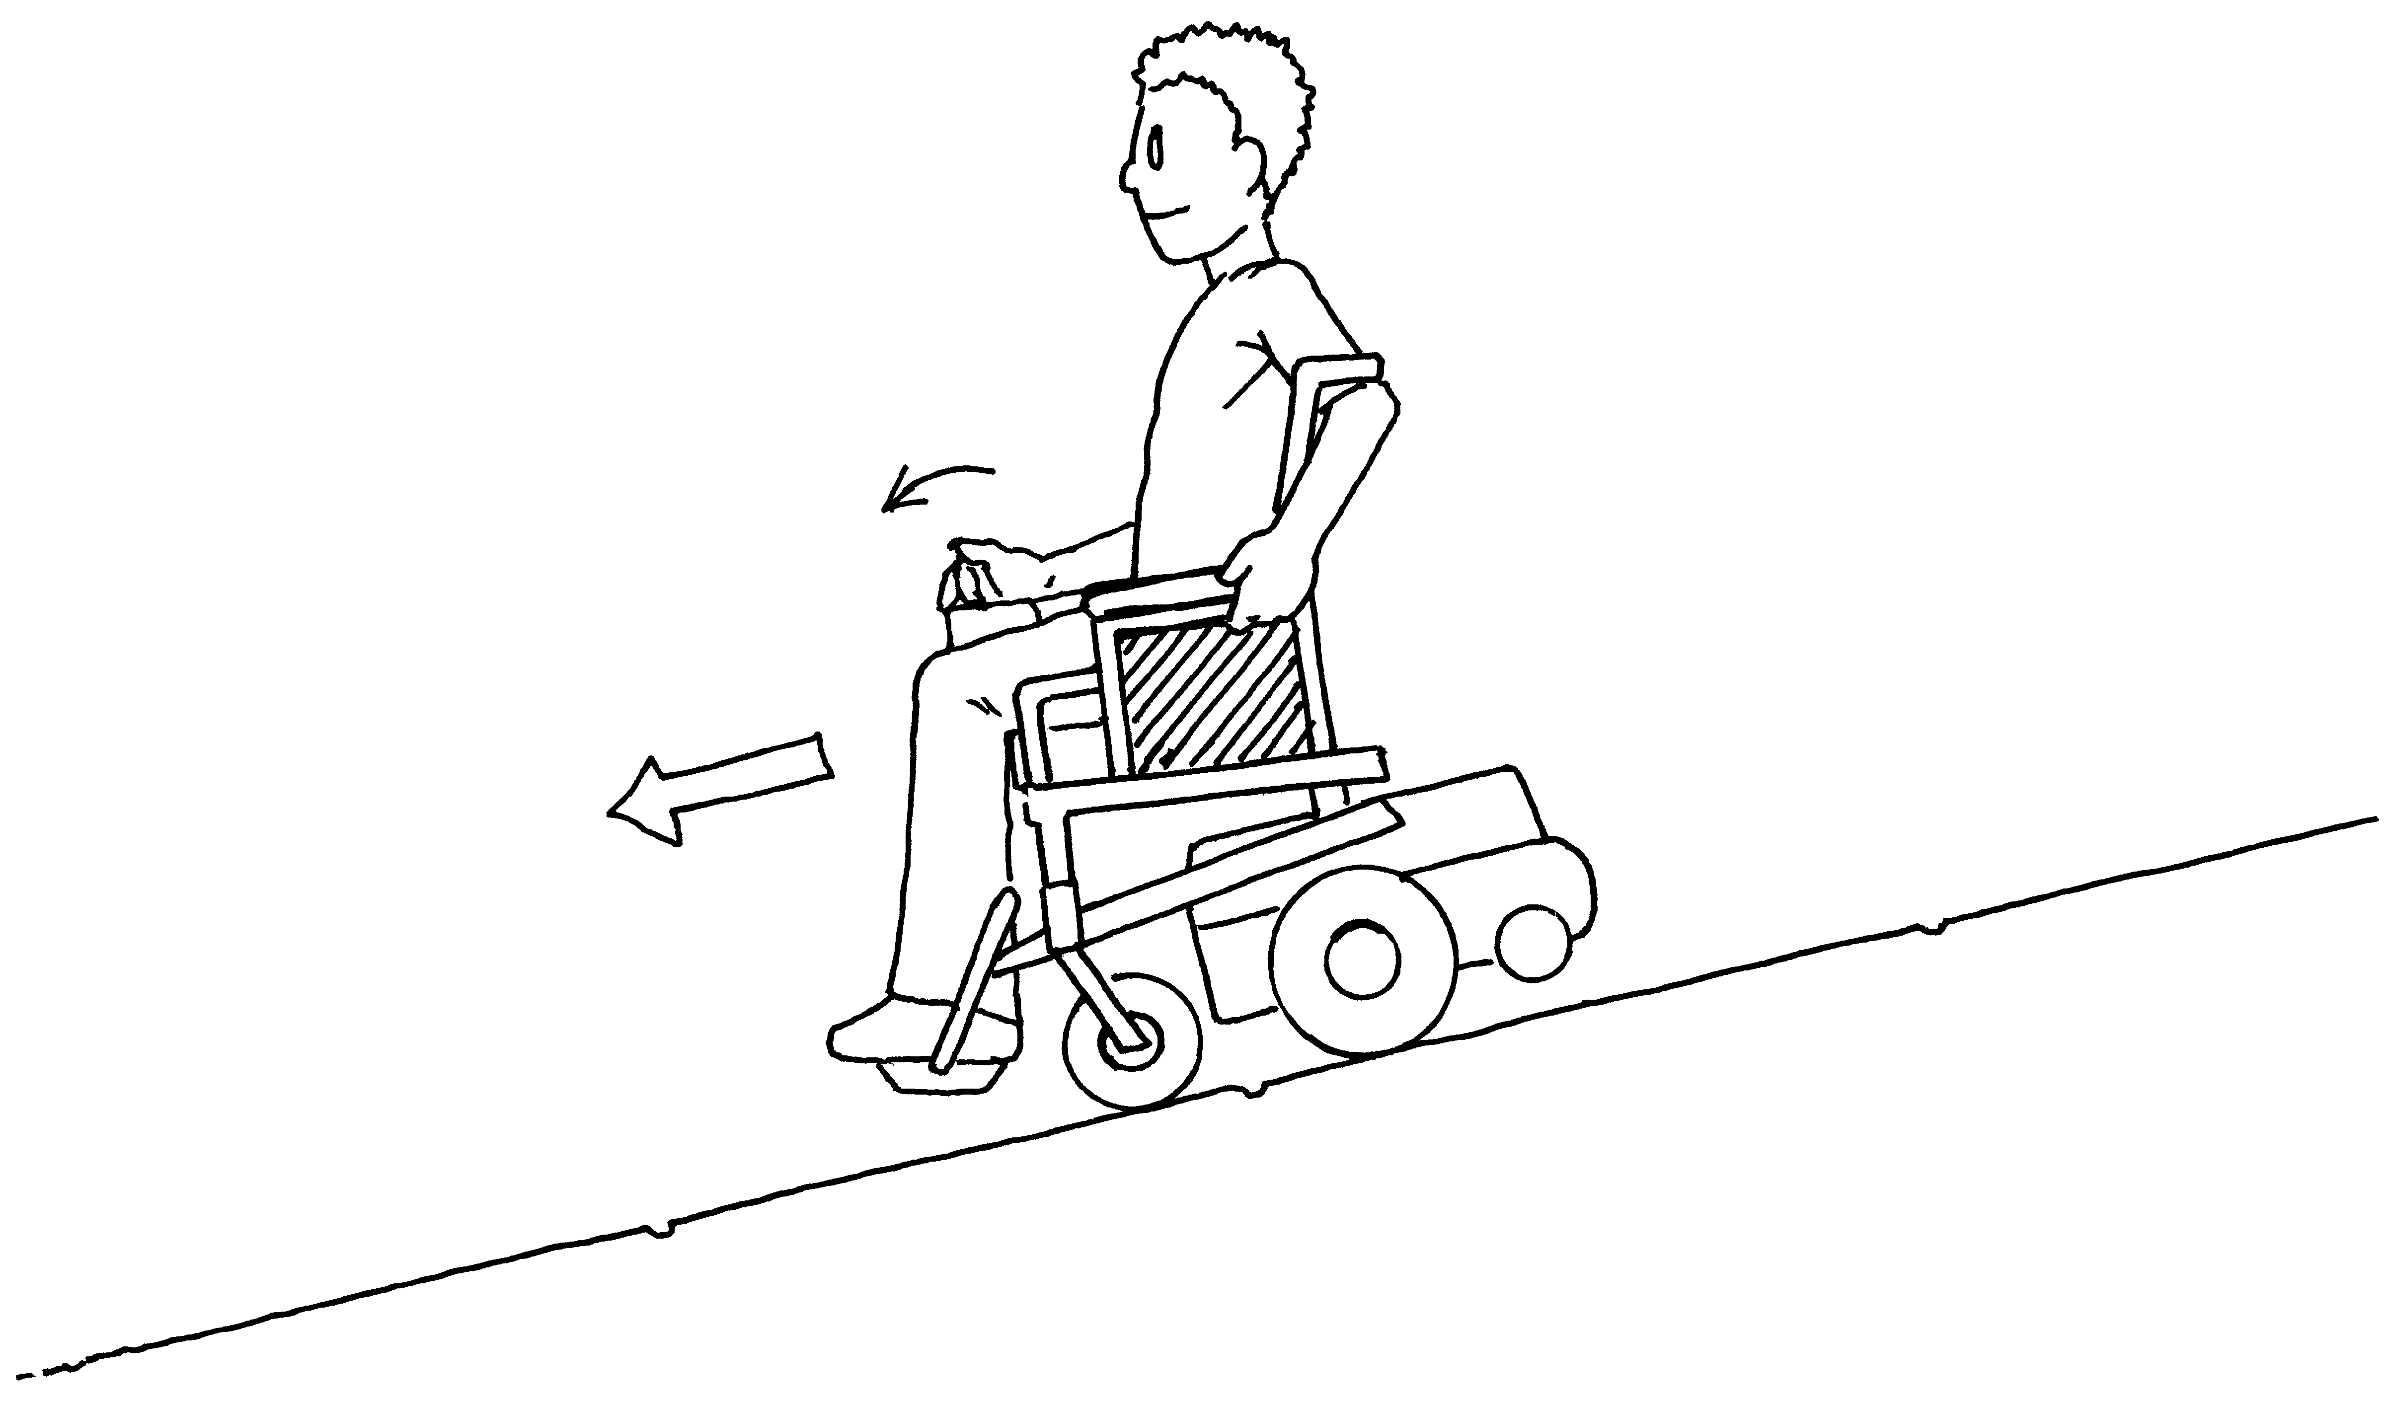

Image reprinted with permission from “The Powered Wheelchair Training Guide” by Axelson, Minkel, Perr, & Yamada. PAX Press. Copyright © 2002. Credit Beneficial Designs.
Ongoing Use & Monitoring:
- Supervisors are responsible for ongoing safe use of the power mobility device.
- The therapist is responsible for setting up a schedule to monitor progress.
- The therapist should be contacted for reassessment prior to the power mobility device being used in any new environment (e.g., that has not yet been evaluated or trained, such as when learning to drive outdoor or in the community) and/or if the child’s skill level changes.

Please contact this therapist if additional individuals require training regarding safety and supervision of this child in power mobility use.

Therapist’s Name: ________________________________________________________
Date: __________________________________________________________________

Copies:
References:
Axelson P, Minkel J, Perr A, Yamada D. (2002). The Powered Wheelchair Training Guide. PAX Press.

Casey, J., Paleg, G., & Livingstone, R. (2013). Facilitating child participation through power mobility. British Journal of Occupational Therapy, 76(3), 158-160.

Dunaway, S., Montes, J., O’Hagen, J., Sproule, D.M., Vivo, D.C.D., & Kaufmann, P. (2013). Independent mobility after early introduction of a power wheelchair in spinal muscular atrophy. Journal of Child Neurology, 28(5), 576-582.

Field, D.A., & Livingstone, R.W. (2018). Power mobility skill progression for children and adolescents: a systematic review of measures and their clinical application. Developmental Medicine & Child Neurology, 60(10), 997-1011.

Kenyon, L.K., Farris, J.P., Gallagher, C., Hammond, L., Webster, L.M., & Aldrich, N.J. (2017). Power mobility training for young children with multiple, severe impairments: a case series. Physical & Occupational Therapy in Pediatrics, 37(1), 19-34.

Livingstone, R., & Field, D. (2014). Systematic review of power mobility outcomes for infants, children and adolescents with mobility limitations. Clinical Rehabilitation, 28(10), 954-964.

Livingstone, R. (2010). A critical review of powered mobility assessment and training for children. Disability and Rehabilitation: Assistive Technology, 5(6), 392-400.

Livingstone, R., & Paleg, G. (2014). Practice considerations for the introduction and use of power mobility for children. Developmental Medicine & Child Neurology, 56(3), 210-221.

Nilsson, L., & Durkin, J. (2014). Assessment of learning powered mobility use - Applying grounded theory to occupational performance. Journal of Rehabilitation Research and Development, 51(6), 963-974.

Wright-Ott, C. (1997). The transitional powered mobility aid: a new concept and tool for early mobility. Pediatric Powered Mobility, Developmental Perspectives, Technological Issues, Clinical Approaches, Arlington, VA, RESNA.

